Potsdam Fibromyalgia Support Group
Newsletter

January, 2016

Gratitude
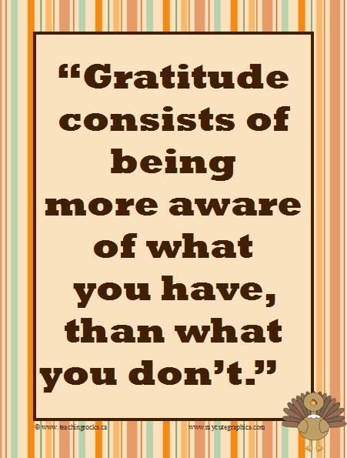
Many people make New Year’s resolutions – usually to change something in their lives. Perhaps, instead of changing something that isn’t ‘good’ about our current lives, we can become more grateful for what is good. In the past decade, studies have shown that people who feel more gratitude tend to be happier and healthier. But what came first, gratitude or better health?
Recent research has included randomized controlled trials (RCTs) that randomly assign subjects to experimental and control groups. This design allows researchers to figure out whether the increases in gratitude caused improved health, or were related in some other way. One such study showed that adding a gratitude activity improved quality of sleep, decreased blood pressure, decreased anxiety and depression (Jackowski, 2015). They had subjects write a ‘gratitude diary’ in which they expressed gratitude for previously unappreciated people and things in their lives. They wrote in this diary at least 3x/wk for 2 wk. One control group wrote about daily events and another control group did not write at all.
Another study found that simply keeping a weekly list of ‘blessings’ was associated with improved quality of sleep and waking feeling more refreshed. (Emmons & McCullough, 2003) An interesting finding from the research is that, while gratitude results in some improvements over the neutral control (just writing about daily activities), it results in more dramatic mental and physical health improvements when compared to people keeping track of daily hassles. This highlights the fact that it may be just as important to avoid negative thoughts as it is to increase positive thoughts. (Wood et al, 2010)
Researchers don’t know how gratitude works to improve health. Here are some hypotheses. (Wood, 2010)
- The first hypothesis was that gratefulness might result in more positive affect, or better mood, which improved overall life satisfaction. However, research suggests this is not the actual mechanism.
- Coping strategy hypothesis: Grateful people may be better linked to social support and may be more socially engaged. This may encourage better coping strategies.
- Broaden-and-build hypothesis: positive emotions broaden thought processes and stimulate creativity, curiosity, social networking and planning ability. In contrast, negative emotions tend to narrow attention to focus on specific problems. Research seems to support this the most.
Methods of adding gratitude into your life:
- Keep a journal of things for which you are grateful – either nightly, several times per week or once a week. Or do it any time you are inspired to. Some recommendations allow you to repeat, while some encourage you to identify different things each time. Suggestions:
  - Don’t just rush through this as an obligation, but really take time to appreciate what is on your list. The more thought you put in, the more likely you will do better writing in your gratitude journal only 1-3 times a week rather than daily.
  - Add notes to your simple list, explaining why you are grateful for each item on the list. Doing this allows you to re-read your list and remember the details of your initial gratitude, which stimulates more good feelings.
  - Focus on people and experiences rather than things.
  - Avoid negativity in your gratitude journal. If you want to talk about challenges and struggles, use a different journal.
  - Give it at least 3 weeks to see if it helps.
- Write a gratitude letter to a living person who has added joy or value to your life; perhaps deliver it in person.
- Take a daily photograph of one thing for which you are grateful. 365Grateful.com is a group that encourages people to find and photograph one thing to be grateful for each day. The web site shares some amazing stories of people who did this.
- For those who are more likely to do it if there is an app, there are several apps you can check out.
Some people with chronic pain or chronic illnesses have trouble thinking of things to be grateful for. If you struggle with this, some ideas to get you started:
- Think about the Big picture: Are you physically safe right now? Can you be grateful you don’t live in a war-torn country?
- Think about people: Do you have friends or family who care about you? Is there a child or grandchild who gives you moments of joy?
- Look around you – do you see, hear, smell or feel anything you could appreciate? Is the sun shining? Is there a beautiful view out the window? A bird at the feeder? Is a loving pet nearby? Can you hear wind chimes? Can you see a photograph that reminds you of good people and good times in your life?
On-line resources:
- TinyBuddha: Pain to Joy: 11 Tips for a Powerful Gratitude Journal: http://tinybuddha.com/blog/turn-pain-to-joy-11-tips-for-a-powerful-gratitude-journal/
- 365grateful.com for the photo gratitude project.
- my.happify.com is an organization founded on the belief that happiness is a skill we can learn and practice.

Research used in this article:
- Emmons RA, McCullough ME. Counting blessings versus burdens: an experimental investigation of gratitude and well-being in daily life. J Pers Soc Psychol. 2003;84(2):377-389.
- Jackowska M et al. The impact of a brief gratitude intervention on subjective well-being, biology and sleep. J Health Psych. 2015:ePub ahead of print.
- Wood AM, Froh JJ, Geraghty AWA. Gratitude and well-being: A review and theoretical integration. Clin Psych Rev. 2010;30

Join us on Facebook!
Before I left for Australia, we started a Facebook page to encourage interaction among members outside of scheduled meetings. It hasn’t gone far because we have not had enough people join. But winter is a good time to connect without leaving your home. And I have posted lots of useful documents are there: old newsletters, handouts (such as the diagnostic criteria, etc.). This provides an opportunity for people to comment on old topics, and start new discussions. For now, the group is only open to people in our Potsdam Fibromyalgia Support Group. To join, contact Kris at: kris.a.lisdesigns37@gmail.com

2010 Diagnostic Criteria for Fibromyalgia
One of our previous meetings included a brief discussion of the fact that the 18 tender points are no longer the basis for diagnosing FM. If you have not yet seen the 2010 American College of Rheumatology (ACR) diagnostic criteria for FM, a copy is available on our Support Group web site, as well as the Facebook page. Briefly:

A patient satisfies diagnostic criteria for fibromyalgia if the following 3 conditions are met:
- Widespread Pain Index (WPI) ≥7 and Symptom Severity (SS) scale score ≥5
OR WPI is 3–6 and SS scale score ≥9.
- Symptoms have been present at a similar level for at least 3 months.
- The patient does not have a disorder that would otherwise explain the pain.

The WPI is based on 19 locations in the body that may have pain. The SS is based on 4 questions about your symptoms: fatigue, trouble concentrating, waking up unrefreshed, and other symptoms such as abdominal pain, headaches or depression (the full list is much longer). Proper diagnosis requires a knowledgeable health care provider, particularly because of the criterion that there is no other condition that would explain the symptoms. People with FM almost always have multiple conditions, so this can be difficult to tease out.

Tuesday, January 5th Fibromyalgia Support Group Meeting:
The Potsdam Fibromyalgia Support Group will meet noon-1 pm on Tuesday, January 5th. The topic is "Gratitude.” Research suggests that gratitude can improve overall physical and mental health, improve quality of sleep, increase function and satisfaction with life. This meeting will encourage discussion of things for which we are grateful and how we can build on gratitude to improve our health. Anyone with a chronic illness is welcome, as are friends and family.

This newsletter is a joint effort of Clarkson University and Canton-Potsdam Hospital. If you would like to receive these newsletters electronically, please send your email address to lrussek@clarkson.edu. You can access current and previous Potsdam Fibromyalgia Support Group Newsletters on our web site: www.people.clarkson.edu/~lnrussek/FMSG.

