Potsdam Fibromyalgia Support Group
Newsletter

December, 2015

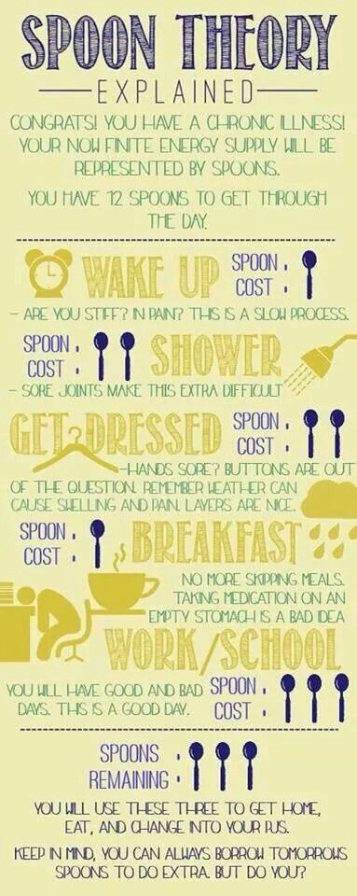
The Spoon Theory
At last month’s support group meeting we had an excellent discussion about having limited energy resources to accomplish what we want. A couple of people described “The Spoon Theory,” which was originally created by someone with lupus, but which applies equally well to many chronic conditions, including fibromyalgia. Since several people had not heard of The Spoon Theory (hereafter: ‘Spoons’), this month’s newsletter will describe it and direct people towards additional resources.
The story is that a young woman, Christine Miserandino, was trying to explain to a friend what it was like to have lupus. They were in a diner, so spoons were the visual at hand. Christine gathered all the spoons she could find and handed 12 to her friend, then explained how every task in the day required one or more spoons. When you have a chronic illness, you have fewer spoons than other people and simple tasks use up more spoons. For example, just getting out of bed in the morning can be exhausting. Taking a shower might cost 2 more spoons if you wash your hair. The graphic at right is one person’s estimate of spoon-cost for different activities.
Graphic from https://www.pinterest.com/pin/460070918162329517/. Not sure who originally created it.
The power of Spoons is that you realize everything involves making choices. If you plow through your day without making decisions, your spoons will be used up and you might not have made it through the afternoon. When your spoons are gone, you either crash for the day or work off spoons borrowed from tomorrow. If you borrow spoons, tomorrow will just be that much more difficult.
One of the challenges of having a chronic illness is that this doesn’t go away. If a healthy person gets the flu, they may have to count spoons for a week or so. But people with chronic illnesses have to do this every single day – figure out what they can do and acknowledge all the things they cannot do even though they want to.
The spoon image can be a powerful metaphor for communication. It gives you a humorous way to discuss your limitations and the fact that you have to choose how to use your limited energy. Even children can understand the concept of making choices: Mom only

has 3 spoons after dinner; she can either clear the table, help you with your homework, or play a game, but she can only do one of those.
And don’t forget to save at least a spoon or two to do something good for yourself! Do something that recharges your batteries, makes you feel better, restores your health. Don’t let other people use your spoons unless it is something you truly value. Perhaps playing games with your grandchildren uses 8 spoons – most of what you have for the day… that’s okay if you are happy to have made that decision. Maybe going to that holiday party is worth borrowing from tomorrow. Or perhaps it isn’t worth it… now you have the language to explain it.

How can you use Spoons in your life?
- As a metaphor to describe how much energy you have on a given day. If your typical day has 20 spoons, a good day might have 25 and a bad day might have just 10. Now, on a mediocre day, you can just tell your partner “I’ve got 12 spoons today” and he/she will understand.
- To involve other people in your decisions about how you will use your spoons. Maybe you have 5 spoons to spend in an evening; you can either cook dinner or go to a movie, but not both. This gives you the language to explain your options to others.
- To help you make decisions about how to use your spoons. Rather than use or waste them early in the day, you might save them for something important to you. Or you might deliberately avoid an activity that will tire you so that you will have spoons for something you enjoy.
- To help you accept your choices. Maybe a long drive to visit family uses 4 spoons, but you want to do it. Remembering that you chose to do this can help you maintain a positive attitude as you recover.
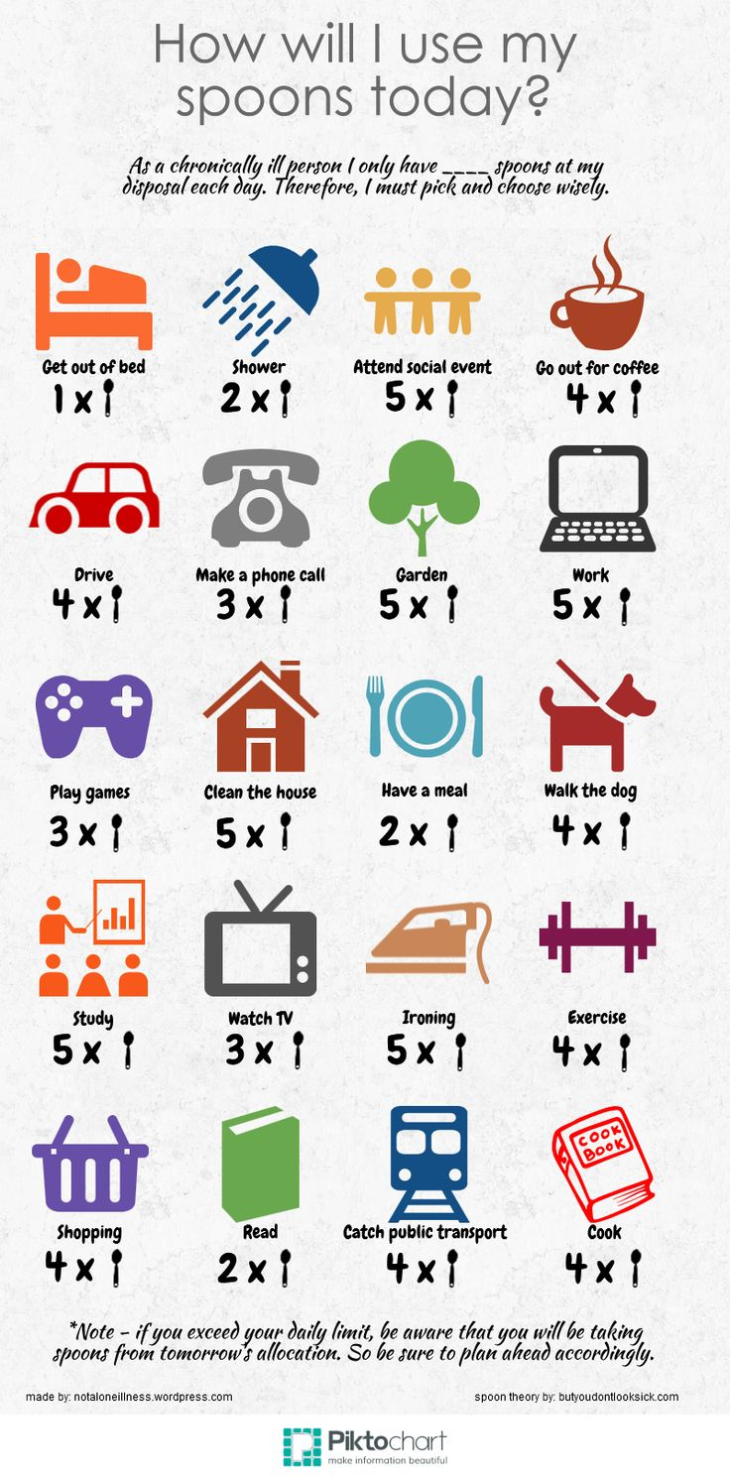
Christine has a wonderful quote in her article. “Don’t worry. I see this as a blessing. I have been forced to think about everything I do. Do you know how many spoons people waste everyday? I don’t have room for wasted time, or wasted “spoons” and I chose to spend this time with you.” (See ButYouDontLookSick, below)
Graphic from: https://notaloneillness.wordpress.com/2014/07/21/choose-your-spoons-2/

Resources:
- The original Spoons Theory story, by Christine Miserandino: http://www.butyoudontlooksick.com/articles/written-by-christine/the-spoon-theory/
- Pinterest has a fun collection of posters and graphics on TST at https://www.pinterest.com/explore/spoon-theory/

Tuesday, December 8th Fibromyalgia Support Group Meeting:
The Potsdam Fibromyalgia Support Group will meet noon-1 pm on Tuesday, December 8th. The topic is "Using the Spoon Theory of energy to prioritize, pace ourselves, and communicate." This support group session will discuss the spoon model and how we can use it to prioritize and communicate better with others why we have to be selective about how to use our energy.

This newsletter is a joint effort of Clarkson University and Canton-Potsdam Hospital. If you would prefer to receive these newsletters electronically, please send your email address to lnrussek@clarkson.edu. You can access current and previous Potsdam Fibromyalgia Support Group Newsletters on our web site: www.people.clarkson.edu/~lnrussek/FMSG.

