**Potsdam Fibromyalgia Support Group**

**Newsletter**

# April, 2014

**Paula Youmell will give a guest lecture at the April Support Group meeting. Be there!**

# Unweaving the Web of Pain with Whole Food Eating

**Guest Contributor: Paula Youmell, RN, MS, CHC.**

Eating whole foods has been *the* healing equation of holistic healers since the beginning of time. Humans have always known that plants contain amazing healing capacity. Certain plants have affinities for certain tissues and render their healing action on these tissues.

These healing whole foods, of course, include herbs. Herbs we cook with and the herbs used for medicine (often these herbs are interchangeable!) are all derived from plants.

Herbs are amazing food, amazing healing plants, but they work best in the context of a healing lifestyle. If one is looking for a “magic bullet” to fix everything without making healing lifestyle changes, then no, herbs will not whip up magic in your life.

Now, use herbs as the amazing healing tools they are: whole foods... and they weave magic in the human body. Whole foods nourish each and every cell in your body, relieving inflammation, and creating a healing response that includes pain relief.

Whole food eating means feeding our bodies the way nature intended. Whole food nutrition is eating in balance, which in turn keeps the body in balance. Foods grown naturally develop with the right proportion of carbohydrates, proteins, and fats intended for that particular food. They contain balanced vitamins, minerals, phyto-nutrients, and enzymes. This natural balance for each food ensures that the body can properly utilize the nutrients. Natural balance in the body means natural relief from inflammation and pain.

***We are still looking for volunteers to meet (once) with PT students learning about fibromyalgia***

*(see info at end of newsletter)*

*One of the biggest tragedies of human civilization is the precedents of chemical therapy over nutrition. It is substitution of artificial therapy over natural, of poison over food, in which we are feeding people poisons trying to correct the reactions of starvation.* Dr. Royal Lee

As a culture, we have created the same scenario with our healing medicines. We have moved away from whole, natural medicines to the processed, refined, factory made pharmaceuticals that upset balance in the human body.

Herbs, whether ingested as a medicinal infusion, taken as a tincture, or in any other form of herbal medicine are whole foods (as long as the whole herb is used in making the herbal medicine). The nutrients in the herbs: vitamins, minerals, phyto-nutrients, and the nutrients yet to be discovered, are utilized by the body cells to cleanse, nourish, and heal each and every body cell.

So often we get the message from main stream media and medicine: Do NOT use herbs as they are potentially dangerous. This is as crazy as saying that eating beets, apples, or any other natural, whole food is potentially dangerous.

When we eat a beet, an apple, some broccoli, or any whole food, our body digests and absorbs the nutrients in the whole food to nourish our cellular health. The same process of digestion and assimilation of nutrients happens with herbs. Herbs are whole food; herbs are healing medicine.

Herbs are plants (leaf, root, stems, bark, berries, seeds), like a beet or an apple, that have nutritional and healing properties with affinities for certain tissues.

Below are whole herbs and whole foods that create an anti-inflammatory effect in the human body. These anti-inflammatory effects relieve pain!

* **Cherries** help reduce cellular inflammation by neutralizing free radicals in the body. This action can also help to stop tissue inflammation.  Anthocyanins, which give tart cherries their deep red color, have anti-inflammatory properties similar to those in aspirin.
* **Olive Oil** is a powerful anti-inflammatory ingredient in your diet. Olive oil contains chemical constituents that are comparable to over the counter pain medications.

## Sage, Cinnamon, Turmeric, Ginger, Cloves, Garlic, and Cayenne are all anti-inflammatory herbs.

## Green Tea is an excellent source of polyphenols which may help to reduce the inflammation causing free radicals in the body.

## Pineapple contains bromelain which has strong anti-inflammatory effects.

**Nine other herbs for inflammation**: Grow them and eat them in your daily, whole food diet.  Find a good combination in a capsule and take 3 times daily.  Better yet, buy 4 to 5 of these herbs and blend together, encapsulate them yourself!

* Black Pepper
* Basil
* Cardamom
* 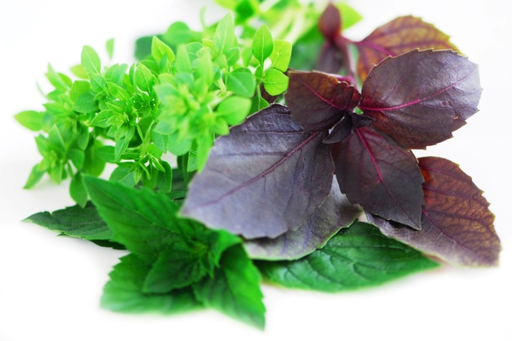Chamomile
* Chives
* Cilantro
* Parsley
* Nutmeg
* Rosemary

**Bottom line**: The foods we feed our body with, set us up for healing through regeneration of healthy body cells OR set us up for illness through degeneration to less healthy body cells. We will explore this relationship of whole foods and whole herbs to health, healing, and relieving pain on Monday, April 28th. Until we meet, be well and focus on whole food eating.

Paula M. Youmell is an RN, author, and Wise Woman Holistic Health Educator and Healer in Northern NY state. Find her at

* www.HandsOnHealthHH.com,
* www.WholeFoodHealer.com, and
* www.wisewomenredtent.com.

**Help PT Students Learn About FMS**

Each year, Clarkson Physical Therapy graduate students learn about fibromyalgia by meeting with volunteers who have FM. This year I am looking for 7-8 people with FMS to come in **Friday, April 25th, 10:15-11:45**. It involves about 60 minutes of talking with 2-3 students and about 30 minutes of allowing them to do a few tests that a PT might do on an initial visit (you do only what you are comfortable doing). If you are available and willing to help, please contact Leslie at 268-3761 or Lnrussek@clarkson.edu. Help make the next generation of health care providers more aware of and sensitive to FMS!

**C:\Users\Leslie Russek\AppData\Local\Microsoft\Windows\Temporary Internet Files\Content.IE5\DRRGYRCA\MC900438205[1].wmfBotox Injections for Depression**

# Recent research suggests that injections of Botox into forehead muscles can decrease depression by 47%, compared to 21% in the placebo group. This was a randomized controlled trial with a placebo group receiving a ‘fake’ treatment. This builds on previous research showing that smiling and laughing can actually improve mood. Prior studies even found that holding a pencil between your teeth (forcing your mouth into a smile) can improve mood. Try smiling – there are no bad side effects!

The botox results were reported in:

* Finzi E, Rosenthal NE. Treatment of depression with onabotulinumtoxinA: A randomized, double-blind, placebo controlled trial. J Psychiatr Res. 2014 May;52:1-6.

# April Fibromyalgia Support Group:

Monday April 28th, 6:30 pm. **Paula M. Youmell, RN, MS, CHHC, Certified Holistic Health Counselor, will talk "Un-weaving the Web of Pain: Using Diet and a Holistic Approach to Manage Pain."** See <http://wholefoodhealer.com/> for information about her.

This newsletter is a joint effort of Clarkson University and Canton-Potsdam Hospital. If you would prefer to receive these newsletters electronically, please send your email address to [lnrussek@clarkson.edu](mailto:lnrussek@clarkson.edu). You can access current and previous Potsdam Fibromyalgia Support Group Newsletters on our web site: [www.people.clarkson.edu/~lnrussek/FMSG](http://www.clarkson.edu/~lnrussek/FMSG).