Potsdam Fibromyalgia Support Group
Newsletter

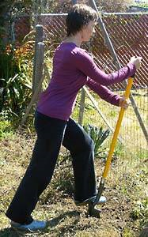
April, 2011

Body Mechanics for Gardening
This is the time of year when many people want to get outside and play in the dirt. Gardening can be very therapeutic – meditative to do, and rewarding to watch things grow. But gardening and yard chores can also be stressful on the body, so it is important that you take care of yourself. Here are some tips.
- Warm up and stretch before you start
  - Walk around the yard a few times to increase circulation and warm up your muscles. This is a good time to look at what needs to be done and do some planning.
  - Do some stretches before you start. This will increase your flexibility and decrease chance of straining your muscles.
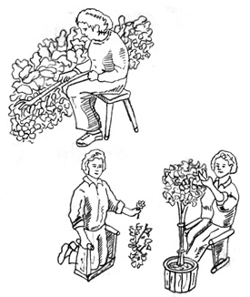
- Plan before you start
  - Have the correct equipment available before you start.
  - Invest in tools that protect your body, especially if you plan to spend a lot of time in the garden. For example, long-handled weeders can save you the strain of bending over the dirt. Carts can protect you from carrying tools and plants. A stool or bench can save you from kneeling. A few sources of adaptive gardening tools are listed at the end of this article.
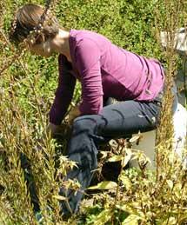
  - Create garden areas that are easier to maintain. Raised beds don’t require as much bending over or weeding. Window boxes are easy to weed and convenient to enjoy. Plant more perennials that need less care. Or plant wildflowers and let part of your garden ‘go wild.’ The birds and wildlife will benefit from the wild areas of your garden.
  - Use mulch and weed block so there are fewer weeds that need pulling. Mulch should be 4-6” thick to prevent weeds from growing.
- Pace yourself
  - Organize projects into smaller modules so you are less inclined to overdo it.
  - Set time limits and rest before you are exhausted or in terrible pain. If you rest after shorter periods of activity, you can often come back and do some more later in the day. If you overdo yourself, you may be out of commission for days. Use a timer if you tend to get engrossed and lose track of the time.
  - Don’t stay in any one position for too long. Resist the temptation to just keep going.
  - Reverse your position for a few minutes every 15-30 minutes. For example, if you are leaning forward, get up and stretch backwards.
  - Alternate activities and positions – sit for 15 minutes then stand for a few minutes.
  - Place chairs or benches at strategic locations so you can stop, rest, and enjoy your garden when you take a rest break.
  - Drink plenty of water so you stay well-hydrated.
- Use good body mechanics.
  - Try to work mostly at trunk level – minimize bending over and reaching overhead. Use a stool to get closer to the ground and a step-ladder or long-armed tools instead of reaching overhead.
  - Don’t carry anything heavy. Use a wheelbarrow or, better yet, a cart doesn’t require lifting to move and is less likely to topple over.
  - If you must shovel dirt, keep your spine straight and take advantage of the leverage the shovel provides.
  - If you need to bend over, bend from the hips and keep your back straight. Don’t round your back or let your head hang down, as that places a lot of stress on the neck and upper back.
  - Use the biggest joints possible to do a task. For example, use your legs to move the shovel rather than pulling with your arms. Use your shoulders to use the trowel rather than using your wrist.
  - Keep your wrists in neutral (mid-range); this maximizes grip strength and minimizes effort.
- Use the right tools.

  - A rolling stool for sitting on or foam pads for kneeling.
Due to a slip of the tongue at the last Support Group meeting, the Potsdam group has a new mascot: Freddy, the Fibrofrog!
  - Get lightweight, ergonomically designed tools. That 20-year old shovel might be twice as heavy as a new one.
  - Long-handled or telescoping tools give you more reach.
  - Keep blades sharp and oiled so they cut with minimum effort.
  - Look for tools made specifically to decrease stress on your body. Some tools have enlarged handles to be easier to grasp. Digging tools with bent handles improve your leverage.
  - If you need to sit, get long-handled tools so you can dig and weed from your chair.
- Sources of adaptive gardening tools:
  - The Wright Stuff: www.wrightstuff.biz; 877-750-0376.
  - Gardening with Ease: www.gardeningwithease.com; 800-966-5119.

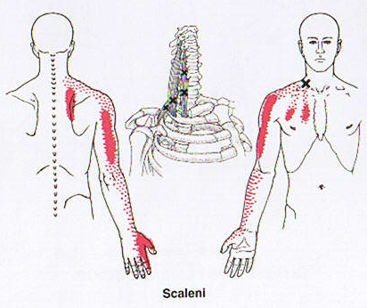
Trigger Pointers: Scalenes

The scalenes are a trio of small muscles in the neck that tilt the neck sideways and lift the top rib for chest breathing. Nerves and blood vessels to the arm pass between the different branches of scalene. Scalene TrP refer pain down the arm, as well as into the chest and shoulder blade areas (see diagram). Left-sided scalene TrP therefore mimics angina or heart trouble. The scalenes can also cause numbness, tingling and swelling. Weakness of the arm due to scalene TrP can lead to dropping things. Scalene TrP can mimic carpal tunnel syndrome, thoracic outlet syndrome, or cervical radiculitis caused by either a bulging disc or arthritis.

The primary factors aggravating scalene TrP is excessive chest breathing, often seen in asthma, smoking, and respiratory problems. Holding the telephone between the ear and shoulder can also provoke these TrP. Whiplash injuries, lifting, poor posture, stress and anxiety are also triggers.
Management of scalene TrP includes practicing diaphragmatic breathing, relaxation, stretching the neck, and avoiding activities that provoke the TrP.

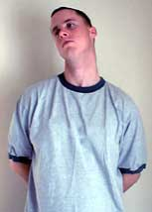
Left-sided scalene stretch: Stand or sit, holding your L hand behind your back using your R hand. Lower L shoulder, tilt head to R to stretch middle scalene; roll head slightly backward to stretch the anterior scalene; roll head slightly forward to stretch posterior scalene. Hold each 15-20 sec. Repeat on other side.

Fibromyalgia Awareness Day

Fibromyalgia Awareness Day is May 12th. We do not yet have specific plans. Stay tuned!

April 25th Potsdam Meeting:
The Potsdam Fibromyalgia Support Group meeting, Monday, April 25th, 6:30 (Note the return to later summer hours!). The topic will be an open discussion on will be: Body Mechanics and pacing: getting more done with less pain. Meetings are still in Clarkson Hall, at 59 Main St. For information about meetings, contact CPH Physical Therapy Department at 261-5460.

May 14th Massena Meeting:
The Massena Support Group will meet on Saturday, May 14th at 1:30 pm. Meetings are on the 2nd Saturday of each month in the Massena Hospital, The May 14th meeting is on “Don’t overdo the Spring thing.” For more information, please contact facilitator Maxine Dodge, at 769-5778.

This newsletter is a joint effort of Clarkson University and Canton-Potsdam Hospital. If you would prefer to receive these newsletters electronically, please send your email address to gilberta@clarkson.edu. You can access current and previous Potsdam Fibromyalgia Support Group Newsletters on our web site: www.people.clarkson.edu/~lnrussek/FMSG.


