Potsdam Fibromyalgia Support Group
Newsletter

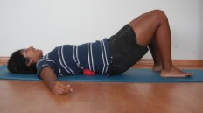
November, 2011


Managing Myofascial Trigger Points

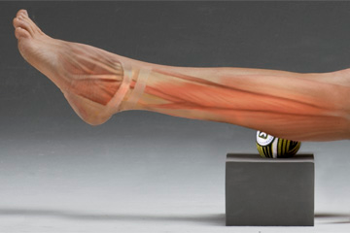
During the past 2 sessions of the Potsdam Fibromyalgia Support Group, Joe Hosmer, PA, has discussed his approach to managing trigger points (TrP). This article will highlight a few of the things he said and discuss strategies for managing your TrP.
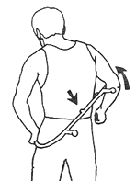
Joe discussed using TrP pressure to relieve TrP. He emphasized that the pressure should be applied slowly until you feel a “good hurt” and held for 8-10 seconds. Pressure should never be painful. Equally important is that the pressure should be released slowly, otherwise deep pressure can cause bruising.
Joe emphasized a few basic principles of massage when performed by an untrained person. First, he said always make sure that pressure is directed towards the heart. This helps fluids in the body return to the heart. He also emphasized the importance of not applying pressure with your thumbs, which are rather fragile joints that can be damaged by too much force applied.
Joe also discussed the benefits of massage, especially if provided with the caring touch of a loved one or friend. He emphasized the importance of intent: if the person providing the massage is truly concerned about the person receiving the massage, that intent comes through. The intent may provide as much of the benefit as the technical skill.
Healing touch has been shown to decrease physical, emotional and spiritual discomfort. It has long been known that premature babies need touch to thrive. Recent studies even show that elderly people with dementia benefit from caring touch as simple as a 5-minute hand massage. Healing touch can benefit the provider, as well. Caregivers often stress because there is so little they can do to help a person with fibromyalgia; providing a massage allows caregivers to show their love and concern in a productive way.
Self-Care for Trigger Points
You can treat your TrP with a combination of pressure and stretching. apply pressure with your hand, with a lacrosse or super ball, or a knobby cane designed specifically for TrP.
Basic principles of using pressure to treat your TrP include:
- Gently lengthen the muscle.
- Apply gentle, gradually increasing pressure until you feel some resistance.
- Hold this resistance until you feel a release or softening under your pressure; this may take anywhere from 10 seconds to a minute.
- You can repeat this process of applying pressure and waiting for the tissues to release.
If you don’t get a release and easing of the pain with pressure, the TrP may be too irritable to tolerate mechanical treatment at this time or you may be applying too much pressure. After applying pressure, the TrP should be gently stretched to restore the normal length of the muscle. Principles of stretching include:
- Stretches should feel good; if it hurts (bad), it is too aggressive.
- Exhale while you apply the stretch; it is difficult to stay tense while you exhale.
- Try a form of stretching called ‘post-isometric relaxation’ where you gently contract the muscle you intend to stretch, hold about 5 seconds, then relax and gently move into the stretch. The principle is that muscles relax more completely after they have contracted. To increase neck side-bending right, you would bend to the right then resist bending to the left (i.e., push right), hold about 5 seconds, then relax and bend further to the right.
- Try ‘reciprocal inhibition’, where you gently contract the opposite muscle, hold for about 5 seconds, then relax and stretch. For example, to stretch into right side-bending of your neck, you would side-bend right, resist bending the neck to the right then, when you relax, you would bend further to the right.
Resources for people interested in learning about trigger points and how to manage them:
- The Trigger Point Therapy Workbook: Your Self-Treatment Guide for Pain Relief, Davies & Davies.
- When Movement Hurts: A Self-Help Manual for Treating Trigger Points, by Barbara J. Headley.
http://www.pressurepointer.com/PressurePointerManual.pdf
Trigger Pointers: Infraspinatus
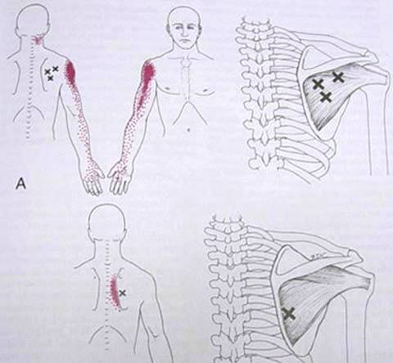
Infraspinatus Referral Pattern
Last month’s newsletter discussed how important TrP are in FM pain. Based on recent research, people with FM are extra sensitive to myofascial TrP, amplifying the TrP pain. The research identifies the most common TrP among people with FM as the the finger extensors, upper trapezius (from shoulder to neck), quadratus lumborum (in the low back), gluteus medius (in the lateral hip), and infraspinatus & supraspinatus (in the shoulder). The infraspinatus is described here.


The infraspinatus is one of the rotator cuff muscles – it rotates the arm out. It can refer pain all the way down to the hand, under the shoulder blade and to the base of the skull. Infraspinatus TrP cause shoulder stiffness, inability to reach behind your back, trouble putting your arm into a coat sleeve, pain sleeping on that side or combing your hair. It can present as a “frozen shoulder” where the shoulder becomes very stiff and weak. Interestingly, treatment of an infraspinatus TrP can restore a significant amount of shoulder motion, even without stretching.
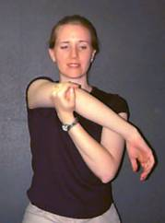
Activities that aggravate the infraspinatus include repeated overhead activities or reaching behind you, grabbing something to prevent a fall, or sleeping on the uninvolved side with the involved arm drooped down.
Corrective actions:
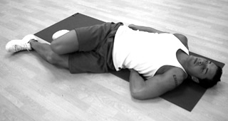
As with most TrP, identify and avoid the aggravating factors. Two infraspinatus stretches are shown here. In the first, hold your arm in front of you with hand rotated down, pull the arm across your body.
In the second stretch, lie on your back with your hips & knees bent, painful hand under your back, palm down. Roll legs towards the arm.

November Potsdam Meeting:
The next meeting of the Potsdam Fibromyalgia Support Group will be Monday, November 14th, at 6:30 pm. “Managing trigger points - a hand's on learning experience” led by Leslie Russek, PT, PhD. This will be a hands-on activity learning how to use lacrosse balls, super-balls, and rolling pins and special devices such as the TheraCane for managing your own trigger points. Participants are encouraged to bring lacrosse balls and rolling pins so that they can practice using these tools to manage trigger points. Wear loose, comfortable clothing. This session will be in the clinical practice lab at Clarkson Hall, at 59 Main St. For information about meetings, contact CPH Physical Therapy Department at 261-5460.

Massena Support Group Meetings:
The Massena Support Group will meet on the 2nd Saturday of each month November 12th at 1:30 in the Massena Hospital. The November topic will be “How do the changing seasons affect your pain?” For more information about the Massena group, please contact facilitator Maxine Dodge, at 769-5778.

This newsletter is a joint effort of Clarkson University and Canton-Potsdam Hospital. If you would prefer to receive these newsletters electronically, please send your email address to gilberta@clarkson.edu. You can access current and previous Potsdam Fibromyalgia Support Group Newsletters on our web site: www.people.clarkson.edu/~lnrussek/FMSG.

