Potsdam Fibromyalgia Support Group
Newsletter

October, 2011

Fibromyalgia vs. Myofascial Pain

Fibromyalgia and myofascial pain often co-exist and people with FM know they have to manage their trigger points (TrP) as part of their pain management. Recent research suggests that people with FM have pain patterns that correspond to TrP patterns. TrP are taut bands within a muscle; these irritated muscle fibers refer pain in the typical patterns we have often discussed in this newsletter. An ‘active TrP’ refers pain even when not pressed, while a ‘latent TrP’ only refers pain when pressed.
Monday, Oct. 24th, 6:30 pm Another special guest lecture:
“Do you know what you are touching? Finding and managing trigger points - a hand's on learning experience.”
by Joe Hosmer, PA.
Joe is a Physician Assistant specializing in muscle pain and dysfunction. He gave an excellent presentation in September, so we asked him to come back again.

Research by Ge, et al, (2011) found that TrP in people with FM were active (i.e., generating pain even when not pressed), while people without FM had latent TrP. This research also found that pain patterns in people with FM often followed typical TrP referral patterns, but were generally more widespread. That is: people with FM had TrP in similar muscles as people who don’t have FM, but pain was present all the time in FM the pain for any given TrP was more widespread.
This same research also looked at which muscles were most likely to have TrP. They found certain muscles were most likely to have TrP: the finger extensors, upper trapezius (from shoulder to neck), infraspinatus & supraspinatus (in the shoulder), quadratus lumborum (in the low back), and gluteus medius (in the lateral hip). The referral pattern from these muscles corresponded to a significant portion of the pain complaints among people with FM. Hence, it appears that TrP may contribute to a substantial amount of FM pain. Previous research suggests that treatment of TrP with anesthetic can significantly reduce FM pain. (Affaitati et al, 2011)
How does this fit with what we know about FM? We know that people with FM have a hypersensitive central nervous system, a condition called ‘central sensitization.’ The TrP may add a peripheral pain generator – that is, a source of musculoskeletal pain that gets amplified by the sensitive FM nervous system. The TrP may also cause ‘peripheral sensitization’ where the peripheral nerves also become hypersensitive. FM may be a situation in which a hypersensitive central nervous system amplifies TrP pain, which in turn amplifies the sensitivity of the central nervous system. That is, FM seems to activate latent TrP.
Another important finding of this study is that certain muscles most likely to have TrP. This can help people with FM identify and manage those TrP. Some of these muscles have been discussed in previous newsletters (still available at http://people.clarkson.edu/~lrussek/FMSG.html): Quadratus lumborum: Nov/Dec, 2009 and Upper trapezius: May, 2008. The gluteus medius is discussed below and other common muscles for TrP will be addressed in upcoming newsletters.
Not all researchers agree with this theory that FM is an amplification of myofascial TrP. Bennett & Goldenberg (2011) argue that researchers are unable to distinguish a myofascial TrP from a FM tender point. Research in upcoming years will hopefully improve our understanding of FM pain.
In the meantime, it appears that managing TrP can help in managing FM pain. Come to the October Potsdam Support Group meeting to learn strategies for identifying and managing your TrP. Also, stay tuned to future newsletters as we continue the intermittent column: Trigger Pointers.
Resources used in this article:
- Ge HY, Wang Y, Fernandez-de-Las-Penas C, Graven-Nielsen T, Danneskiold-Samsoe B, Arendt-Nielsen L: Reproduction of overall spontaneous pain pattern by manual stimulation of active myofascial trigger points in fibromyalgia patients. Arthritis Res Ther. 2011, 13:R48.
- Affaitati G, Costantini R, Fabrizio A, Lapenna D, Tafuri E, Giamberardino MA: Effects of treatment of peripheral pain generators in fibromyalgia patients. Eur J Pain. 2011, 15:61-69.
- Bennett RM, Goldenberg DL. Fibromyalgia, myofascial pain, tender points and trigger points: splitting or lumping? (editorial) Arth Res & Ther. 2011;13:117-120.

Trigger Pointers: Gluteus Medius
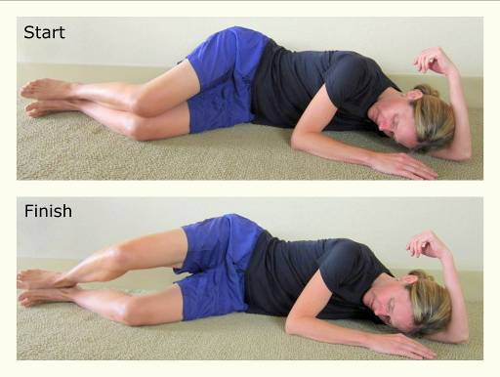
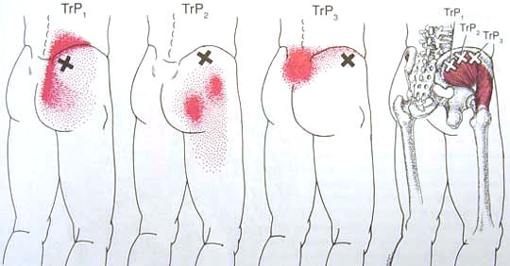TrP in the gluteus medius usually presents as low back pain and needs to be distinguished from ‘lumbago’ and sacro-iliac pain. Pain may also extend down the outside of the hip to the knee and mimic trochanteric bursitis. The referral pattern for the gluteus medius is shown above.
The gluteus medius functions to hold the body upright when you stand on one leg. TrP in this muscle can be caused or aggravated by:
- Walking (especially on soft surfaces), running and climbing stairs.
- A leg length difference (usually the longer leg has pain).
- A Morton foot, in which the 2nd toe is long (this alters the biomechanics of walking)
- Sacro-iliac mal-alignment
- Excessive hip flexion while sitting or sleeping (e.g., sleeping in a fetal position)
- Lying on the involved side.
- Sitting on a thick wallet.
- TrP in the quadratus lumborum (see Nov/Dec 2009 newsletter).
Corrective actions:
- Sleep on the uninvolved side with a pillow between your knees.
- Avoid prolonged immobility, such as sitting or lying down too long, especially with hips flexed.
- Avoid activities involving standing on one leg (e.g., sit while putting pants on).
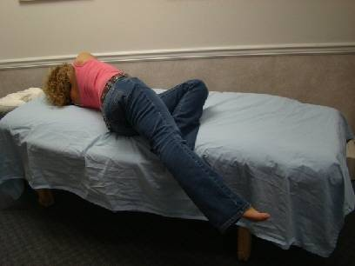
- Correct a leg-length difference, or foot problems if present.
Stretches:
- Lie on your L side.
- Move back towards the edge of the bed.
- Bend L leg 90° at knee and hip.
- Take a deep breath, while exhaling drop R leg back over edge of bed, keeping it straight at the knee. Relax and let the leg drop as far as it can feeling the tightness in the upper buttock and outside of the hip and leg.
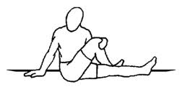
- To increase the stretch, hook L foot over R leg and push R leg downwards.
Another stretch for the posterior gluteus medius is shown right:
Once the TrP is no longer painful, you should strengthen the gluteus medius with exercises such as the “clamshell” shown below:
- Lie on your side, keep both knees bent, flex hips to 30°.
- Keep heels touching and pelvis still, open your knees by contracting your gluteus medius. This is a very slow, small and targeted movement.
- Feel your gluteus medius (below and behind your hip) to ensure it is active during the movement.
- Repeat the movement slowly 10 to 15 times; switch sides.
October Potsdam Meeting:
The next meeting of the Potsdam Fibromyalgia Support Group will be Monday, October 24th, at 6:30 pm. “Do you know what you are touching? Finding and managing trigger points - a hand's on learning experience.” by Joe Hosmer, PA. This will be a hands-on learning experience. People are encouraged to bring a partner to help them work on trigger points. Participants are also asked to bring lacrosse balls, variously sized super-balls, and rolling pins so that they can learn how to use these tools to manage trigger points. Wear loose, comfortable clothing. This session will be in the clinical practice lab at Clarkson Hall, at 59 Main St. For information about meetings, contact CPH Physical Therapy Department at 261-5460.

Massena Support Group Meetings:
The Massena Support Group will meet on the 2nd Saturday of each month November 12th at 1:30 in the Massena Hospital. The November topic will be “How do the changing seasons affect your pain?” For more information about the Massena group, please contact facilitator Maxine Dodge, at 769-5778.

This newsletter is a joint effort of Clarkson University and Canton-Potsdam Hospital. If you would prefer to receive these newsletters electronically, please send your email address to gilberta@clarkson.edu. You can access current and previous Potsdam Fibromyalgia Support Group Newsletters on our web site: www.people.clarkson.edu/~lnrussek/FMSG.




