Potsdam Fibromyalgia Support Group
Newsletter

October, 2009

Acupressure for Fibromyalgia

Acupuncture and acupressure are based on an ancient Chinese tradition of using needles or pressure, respectively, to balance energy flow through the body. The concept is that energy flows through the body along lines called meridians and disease occurs when energy is blocked or excessive along these lines. Acupuncture involves inserting needles at these specific points, while acupressure uses manual pressure at these same ‘acupoints.’ Some recent studies have shown that using a pointed object, such as a toothpick, on an acupuncture point might be as effective as actual needling.
The Chinese were very methodical in their study of meridians and chi, and the first known medical text was written around 300 BC. In past years, Western science has studied many applications of acupuncture. While Western medicine is still unable to explain the physiology of how it works, research has proven the effectiveness of many acupuncture treatments.
Acupuncture is based on the Taoist philosophy of balance between yin and yang. The Chinese character for Yin is the shady side of the hill while the sign for Yang is the sunny side of the hill. The idea is that neither is good nor bad, and that both must be present. The polarity between Yin and Yang leads to the flow of energy, similar to the flow of electrons from the negative to positive pole of a battery. Flow occurs along the meridians. Disease occurs when flow is deficient, stagnant, or excessive. Each meridian reflects a specific organ, such as the heart or bladder.
The actual points may lie on muscle (some are on trigger points), bone, tendon, or other structures. Often the points lie in a slight indentation you can feel, and often the point will be tender to pressure. In fact, most of the FM tender points lie at or near acupuncture points. Auricular acupuncture uses points found on the ear. Reflexology is a similar mapping of the body onto the foot.
The Chinese names for the acupoints often use imagery to indicate their purpose. For example, Joyful Sleep is for insomnia while Hidden Clarity helps clear the mind. Other poetic names include Window of Heaven (good for headaches), Sea of Tranquility (for anxiety), and Sea of Vitality (for fatigue). The Chinese names of the points can be used as a focus for meditation as you breathe deeply and press the point.
Acupressure works very well for some people. Since it is free, has no side effects, and does not interact with medications, it could be beneficial to people with FM. The book “Acupressure’s Potent Points” by Michael Reed Gach is a very easy to follow self-treatment guide. Some of the acupressure protocols in the book include:
- Anxiety and nervousness
- Backache and sciatica
- Chronic fatigue syndrome
- Depression and emotional balancing
- Headaches and migraines
- Indigestion and stomachache
- Insomnia
- Irritability, frustration, dealing with change
- Memory and concentration
- Pain (upper or lower body)
Following is a description of how to use some of the insomnia points described in the Gach book. There is a diagram of the insomnia points on the next page (note that some of the numbers differ between the Gach book and this diagram).
- Inner Gate (P7 on this diagram) is on the inside of the forearm, t.5 finger widths above the wrist crease. This point relieaves insomnia, anxiety, palpitations, nausea and indigestion.
- Spirit Gate (H17 on this diagram) is on the inside of the wrist crease, in line with the little finger. This point relieves anxiety, cold sweats, and insomnia due to over excitement.
- Joyful sleep (K16 on this diagram) is in a slight indentation just below the inside of the ankle bone. This point relieves insomnia, ankle pain, hypertension and anxiety.
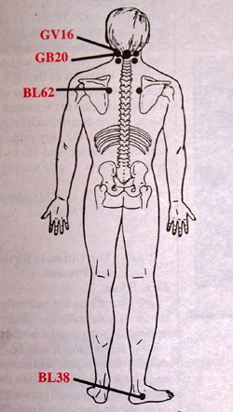
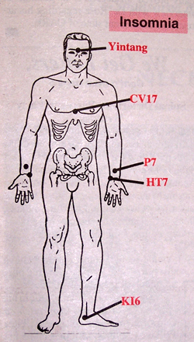

- Calm Sleep (BL38 on this diagram) lies in the indentation just below the outer ankle bone. This point relieves insomnia and back pain.

Come to the October Potsdam FM meeting and learn more about using acupressure points. If you have a friend or family member willing to do acupressure for you, bring that person along, too.

Retrovirus Found in Chronic Fatigue Syndrome
Just last week, reports came out about a retrovirus found in 67% of people with chronic fatigue syndrome (CFS). CFS, like FM, has eluded diagnosis because there has been no definitive test that proves you have it. In the past, the Epstein-Barre virus has been used as a marker for CFS, but not all people with CFS have it. This newly identified retrovirus may improve both diagnosis and treatment options for CFS.


Because of the holiday, there will be one newsletter for November/December.


October Potsdam Meeting:
The Potsdam Fibromyalgia Support Group meeting is Thursday, October 22nd, at 6:30 pm. Using Acupressure to Manage Fibro Symptoms. The meeting will include a brief presentation about acupressure and a hands-on workshop showing how you can do acupressure to yourself. The workshop will focus on treatments for fatigue and insomnia. The group meets in Clarkson Hall, at 59 Main St., Potsdam. For more info about the support group, contact Canton-Potsdam Hospital Physical Therapy Department at 261-5460 or email Lnrussek@clarkson.edu.
NOTE: The November Potsdam meeting will be on Thursday, November 19th (the 3rd Thursday) because of the Thanksgiving holiday. We will also be switching to winter hours: meeting 5:30-6:30.

November Massena Meeting:
Acupuncture point diagram for insomnia from:
Dynamic Chiropractic. 1/14/1994; 12(02) available at http://www.chiroweb.com/mpacms/dc/article.php?id=41034
The Massena Fibromyalgia Support Group will meet on Tuesday, November 10th at 6:30 in Massena Memorial Hospital. Topic: “How Physical Inactivity Leads to Increased Pain and Fatigue.” For more information about the group, contact facilitator Maxine Dodge, at 769-5778.

New Support Group for Psychological Aspects of FM
Reminder that we have a new support group that focuses on the psychosocial aspects of FM. The group meets for approximately one hour each week (you don’t need to make every session) on Fridays from 1-2 pm, in room 223 of Clarkson Hall. For details about the group, check the September newsletter or contact Dianna Newton at 261-4054 or gentlerayn@msn.com (put “Support Group” into the subject line). You can read more about CBT in at the April FM Newsletter, available at: http://people.clarkson.edu/~lnrussek/FMSG.html

This newsletter is a joint effort of Clarkson University and Canton-Potsdam Hospital. If you would prefer to receive these newsletters electronically, please send your email address to gilberta@clarkson.edu. You can access current and previous Potsdam Fibromyalgia Support Group Newsletters on our web site: www.people.clarkson.edu/~lnrussek/FMSG

