
Mathematics Conference and Competition of Northern New York (MCCNNY)

A Conference for Undergraduate and Graduate Students in Northern New York

February 28 and March 1, 2014
Clarkson University
8 Clarkson Ave, Potsdam, NY 13699-5815
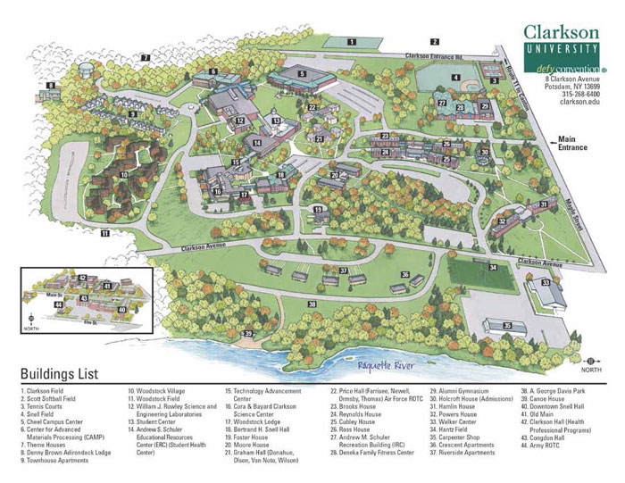
Parking and sessions in Science Center 360 on Friday
Parking and sessions in Snell Hall Saturday (Rooms 212, 213, 214)

