
Mathematics Conference and Competition of Northern New York (MCCNNY)

A Conference for Undergraduate and Graduate Students in Northern New York

February 28 and March 1, 2014
Clarkson University
8 Clarkson Ave, Potsdam, NY 13699-5815

Kenote Address 1：

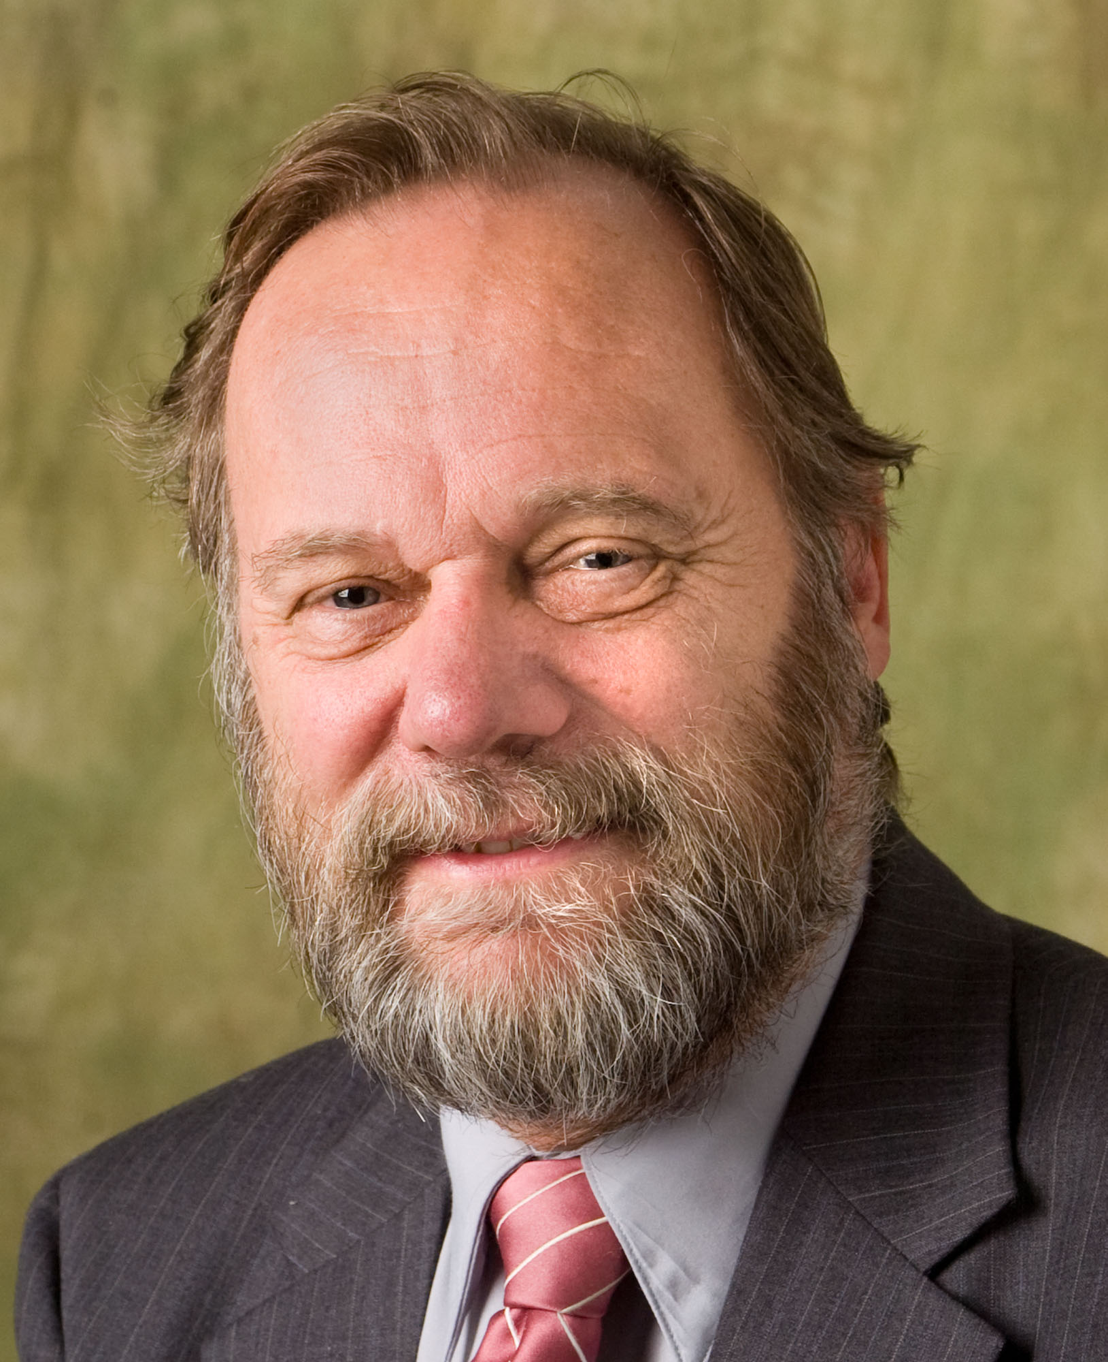
Dr. Peter Turner

Dean of Arts & Sciences
Professor, Mathematics & Computer Science

Clarkson University

Title：Why Math Matters

Abstract: The national emphasis on STEM, STEM education and the STEM workforce is meaningless without a strong core of mathematical thinking. The talk will begin with a look at a few places in which mathematics has had a major impact and opens opportunities for worthwhile careers in academia and beyond. Following that introduction, I will discuss some of the recent developments in the mathematics professional community to address STEM Education and Workforce priorities.

